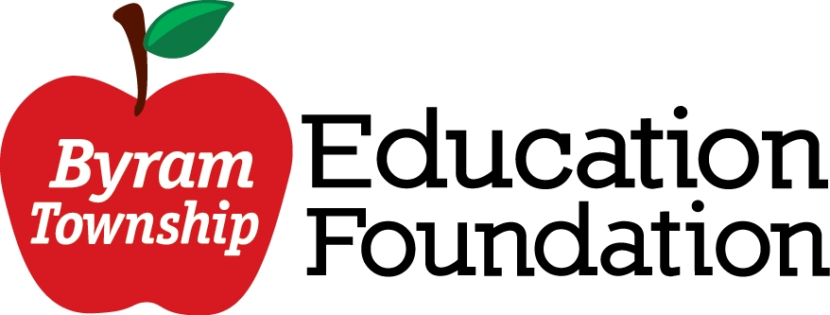

September 2022

Byram Teaching Staff,

We hope the start of the school year has been great for you. Is there something that you need in your classroom to help you enrich the curriculum or do you have a great idea for your grade level or the whole school? The Byram Township Education Foundation (BTEF) will gladly accept your ideas and hopefully we will be able to support your ideas and approve your grant. As teachers ourselves, we understand that this is a very busy time of the year for you as you are just settling into the school year. With that said, this is a great time to think about what you might need to support your curriculum for the school year.

The grants should support the mission of the BTEF which is to support excellence in learning and enhance the educational experience of our students. The BTEF seeks to fund fresh ideas in education that aim to teach in innovative ways. Proposals should capture the attention and meet the needs of 21st century learners. We are also looking to fund grants that focus on improving the literacy skills of the students.

Grant awards may be used for any combination of materials, training, professional speakers, technology, etc. Funds cannot be used to purchase curriculum materials that are traditionally purchased through the regular school budget.

Attached is an application that needs to be completed and then approved by your building principal. Then it needs to be sent and approved by Mr. Fritzky. Once that is done, you can then email it to: byrameducationfoundation@yahoo.com.

The grants will be reviewed on a first come first serve basis. The BTEF will blindly review all of the proposals and you will hear back from us in about a month.

If you have any questions, please feel free to contact Kristen Miller at byrameducationfoundation@yahoo.com.

Sincerely,

Byram Township Education Foundation

Byram Township Education Foundation (BTEF)
“Empowering Educators and Enriching our Students” Grant 2022-2023

COVER SHEET

Name: _____________________________________________

Email: _____________________________________________

School: ____________________________________________

Grade/Subject/Specialty: ____________________________

Grant Title: ________________________________________

Budget: ____________________________________________

Building Principal Signature: __________________________

Superintendent Signature: ____________________________

Please submit grants by email to:
byrameducationfoundation@yahoo.com

Byram Township Education Foundation (BTEF)
“Empowering Educators and Enriching our Students” Grant
2022-2023

APPLICATION

Please answer the following questions (Sections I, II, III, IV, and V), using the headings below.

*DO NOT include your name of this part of the application*

- Statement of Purpose (limt 250 words):

What is the aim of your grant proposal?

What part of the school and/or district goals are addressed with your proposal?

What part(s) of the curriculum would be enhanced by your proposal?

How will you program enrich the educational experience of your students?

- Implementation (limit 500 words):

Who would benefit from your proposal? Approximately how many students would be involved in the program or project activities?

What is the time frame for implementing your proposal?

If the purchase of technology is part of your proposal, describe how such technology will enhance learning.

Can the project or activities be replicated? If so, how would this occur?

- Innovation and/or Creativity (limit 250 words):

Describe the innovative and/or creative elements of you program or project that would capture the attention of the 21st century learner.

- Budget

Identify the material(s) that would be purchased through the grant. Submit an itemized budget, including shipping and handling charges, if applicable.

Please list any other funding sources to which you have applied or fund you have been granted to support this program or project.

- Evaluation

How will you evaluate the success of your program or project
(i.e. its impact on student performance)?

THANK YOU FOR TAKING THE TIME TO COMPLETE THE APPLICATION!

BTEF Grant Evaluation Process

Proposals will go through a blind evaluation based on the following criteria:

- Supports district and school goals
- Supports and enhances the curriculum
- Is creative and innovative
- Can be replicated
- Clearly defined budget
- Provides evaluation

Grant will be awarded on a first come first serve basis. You will get approval within a month from your submission. Approved materials will be purchased by the BTEF and donated to the Byram Township School District.

If you have any questions or comments, please email Kristen Miller, BTEF president, at byrameducationfoundation@yahoo.com. Further information about the Byram Township Education Foundation (BTEF) can be found on the BTEF website: btef.weebly.com

